**Login Modual**

using System;

using OpenQA.Selenium;

using OpenQA.Selenium.Chrome;

using OpenQA.Selenium.Support.UI;

using System.Threading;

namespace Automate_BMW_Website

{

classlogin

{

publicvoid loin()

{

//chrome web browser will open

IWebDriver driver = new ChromeDriver();

//Maximize method is to maximize the screen

//open BMW website

driver.Url = "https://www.bmw.in/en/index.html";

Thread.Sleep(10000);

driver.Manage().Window.Maximize();

Thread.Sleep(10000);

//open cart

driver.FindElement(By.XPath("//*[@id='id-shopping-cart_desktop']")).Click();

Thread.Sleep(5000);

//Login in icon

driver.FindElement(By.XPath("//*[@id='navbarNavAltMarkup']/div/div/ul/li/a/i")).Click();

Thread.Sleep(2000);

////Click Register now

//driver.FindElement(By.XPath("//*[@id='wrapper']/div/div/div[1]/div/button")).Click();

//Thread.Sleep(2000);

////select gender

//driver.FindElement(By.XPath("//*[@id='salutation']")).Click();

//Thread.Sleep(2000);

////Enter first name

//driver.FindElement(By.XPath("//*[@id='first-name']")).SendKeys("mohanraj");

//Thread.Sleep(2000);

////Enter last name

//driver.FindElement(By.XPath("//*[@id='last-name']")).SendKeys("R");

//Thread.Sleep(2000);

////Enter Email

//driver.FindElement(By.XPath("//*[@id='email']")).SendKeys("mohanrajramu619@gmail.com");

//Thread.Sleep(2000);

////Enter password

//driver.FindElement(By.XPath("//*[@id='password']")).SendKeys("Mohanraj(619)");

//Thread.Sleep(2000);

////Click check box

//IWebElement option1 = driver.FindElement(By.XPath("//*[@id='wrapper']/div/div/div[1]/div/form/div[8]/div/div/div[1]/div"));

//option1.Click();

//Thread.Sleep(2000);

////Click Register

//driver.FindElement(By.XPath("//*[@id='wrapper']/div/div/div[1]/div/form/div[9]/button")).Click();

//Thread.Sleep(2000);

////Back to login

//driver.FindElement(By.XPath("//*[@id='resendEmail']/button[2]")).Click();

//Thread.Sleep(2000);

//Enter the mail id

IWebElement dr = driver.FindElement(By.XPath("//*[@id='email']"));

dr.SendKeys("mohanrajramu619@gmail.com");

if (dr.Text.Equals("mohanraj@gmail.com"))

{

Console.WriteLine("Enter Valid E-Mail ID");

ITakesScreenshot screenshotDriver = driver as ITakesScreenshot;

Screenshot screenshot = screenshotDriver.GetScreenshot();

screenshot.SaveAsFile("link.png", ScreenshotImageFormat.Png);

driver.Quit();

}

else

{

//Hint: User name: mohanrajramu619@gmail.com

//Password:Mohanraj(619)

////Click on Continue Button

//driver.FindElement(By.XPath("//*[@id='create-account']/div/div/div/div/div[2]/div[4]/div/form/div[2]/span[3]/button")).Click();

//Thread.Sleep(15000);

//Enter the password

IWebElement pass = driver.FindElement(By.XPath("//*[@id='password']"));

pass.SendKeys("mohanraj619");

if (pass.Text.Equals("mohanraj619"))

{

Console.WriteLine("Enter Valid password");

ITakesScreenshot sd = driver as ITakesScreenshot;

Screenshot ss = sd.GetScreenshot();

ss.SaveAsFile("link.png", ScreenshotImageFormat.Png);

//Forgot password

driver.FindElement(By.XPath("//*[@id='wrapper']/div/div/div[1]/div/form/div[3]/div[1]/p/a")).Click();

Thread.Sleep(2000);

//Enter Email id

driver.FindElement(By.XPath("//*[@id='email']")).SendKeys("mohanrajramu619@gmail.com");

Thread.Sleep(2000);

//Click Request Button

driver.FindElement(By.XPath("//*[@id='wrapper']/div/div/div[1]/div/form/div[2]/button")).Click();

Thread.Sleep(2000);

//Back To login

driver.FindElement(By.XPath("//*[@id='wrapper']/div/div/div[1]/div/button")).Click();

Thread.Sleep(2000);

driver.Quit();

}

else

{

//Click the login Button

driver.FindElement(By.XPath("//*[@id='wrapper']/div/div/div[1]/div/form/div[3]/div[2]/button")).Click();

Thread.Sleep(5000);

ITakesScreenshot screenshotDriver = driver as ITakesScreenshot;

Screenshot screenshot = screenshotDriver.GetScreenshot();

screenshot.SaveAsFile("link.png", ScreenshotImageFormat.Png);

Thread.Sleep(10000);

//update your profile

//Enter mobile number

driver.FindElement(By.XPath("/html/body/app-root/app-layout/app-my-profile/p-dialog[2]/div/div[2]/form/div[1]/div[3]/app-otp/form/div/input")).SendKeys("6381014927");

Thread.Sleep(2000);

//Click update button

driver.FindElement(By.XPath("//*[@id='button-addon2']")).Click();

Thread.Sleep(2000);

//Enter pincode

driver.FindElement(By.XPath("//*[@id='zip']")).SendKeys("638011");

Thread.Sleep(2000);

//Select city

SelectElement city = new SelectElement(driver.FindElement(By.XPath("//*[@id='City']")));

city.SelectByValue("ERODE");

Thread.Sleep(2000);

//Enter address line1

driver.FindElement(By.XPath("//*[@id='address2Street1']")).SendKeys("sangu nagar 3rd street");

Thread.Sleep(2000);

//Select gender

SelectElement gender = new SelectElement(driver.FindElement(By.XPath("//*[@id='gender']")));

gender.SelectByValue("Male");

Thread.Sleep(2000);

//Click calender

driver.FindElement(By.XPath("/html/body/app-root/app-layout/app-my-profile/p-dialog[2]/div/div[2]/form/div[12]/div[4]/p-calendar/span/button")).Click();

Thread.Sleep(2000);

//Click month

SelectElement month = new SelectElement(driver.FindElement(By.XPath("/html/body/app-root/app-layout/app-my-profile/p-dialog[2]/div/div[2]/form/div[12]/div[4]/p-calendar/span/div/div/div[1]/div/select[1]")));

month.SelectByValue("6");

Thread.Sleep(2000);

//Click year

SelectElement year = new SelectElement(driver.FindElement(By.XPath("/html/body/app-root/app-layout/app-my-profile/p-dialog[2]/div/div[2]/form/div[12]/div[4]/p-calendar/span/div/div/div[1]/div/select[2]")));

year.SelectByValue("2000");

//Click date

driver.FindElement(By.XPath("/html/body/app-root/app-layout/app-my-profile/p-dialog[2]/div/div[2]/form/div[12]/div[4]/p-calendar/span/div/div/div[2]/table/tbody/tr[3]/td[7]/a")).Click();

Thread.Sleep(2000);

//Click Occupation

SelectElement occu = new SelectElement(driver.FindElement(By.XPath("//*[@id='occupation']")));

occu.SelectByValue("Salaried");

Thread.Sleep(2000);

//Enter hobbies

driver.FindElement(By.XPath("//*[@id='hobbies']")).SendKeys("Reading story books");

Thread.Sleep(2000);

SelectElement primarycar = new SelectElement(driver.FindElement(By.XPath("//*[@id='primarycar']")));

primarycar.SelectByValue("True");

Thread.Sleep(2000);

driver.FindElement(By.XPath("/html/body/app-root/app-layout/app-my-profile/section/section[1]/div/div[2]/form/div[20]/div/button[3]")).Click();

Thread.Sleep(2000);

}

}

}

}

}

**Incorrect Password**

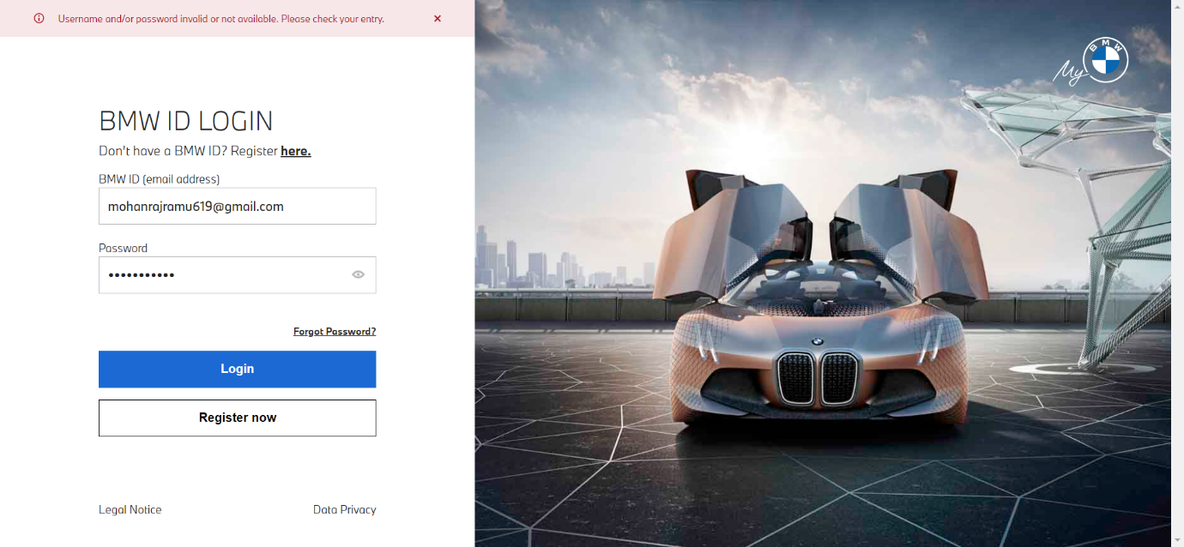

**Profile Update Modual**

//update your profile

//Enter mobile number

driver.FindElement(By.XPath("/html/body/app-root/app-layout/app-my-profile/p-dialog[2]/div/div[2]/form/div[1]/div[3]/app-otp/form/div/input")).SendKeys("6381014927");

Thread.Sleep(2000);

//Click update button

driver.FindElement(By.XPath("//*[@id='button-addon2']")).Click();

Thread.Sleep(2000);

//Enter pincode

driver.FindElement(By.XPath("//*[@id='zip']")).SendKeys("638011");

Thread.Sleep(2000);

//Select city

SelectElement city = new SelectElement(driver.FindElement(By.XPath("//*[@id='City']")));

city.SelectByValue("ERODE");

Thread.Sleep(2000);

//Enter address line1

driver.FindElement(By.XPath("//*[@id='address2Street1']")).SendKeys("sangu nagar 3rd street");

Thread.Sleep(2000);

//Select gender

SelectElement gender = new SelectElement(driver.FindElement(By.XPath("//*[@id='gender']")));

gender.SelectByValue("Male");

Thread.Sleep(2000);

//Click calender

driver.FindElement(By.XPath("/html/body/app-root/app-layout/app-my-profile/p-dialog[2]/div/div[2]/form/div[12]/div[4]/p-calendar/span/button")).Click();

Thread.Sleep(2000);

//Click month

SelectElement month = new SelectElement(driver.FindElement(By.XPath("/html/body/app-root/app-layout/app-my-profile/p-dialog[2]/div/div[2]/form/div[12]/div[4]/p-calendar/span/div/div/div[1]/div/select[1]")));

month.SelectByValue("6");

Thread.Sleep(2000);

//Click year

SelectElement year = new SelectElement(driver.FindElement(By.XPath("/html/body/app-root/app-layout/app-my-profile/p-dialog[2]/div/div[2]/form/div[12]/div[4]/p-calendar/span/div/div/div[1]/div/select[2]")));

year.SelectByValue("2000");

//Click date

driver.FindElement(By.XPath("/html/body/app-root/app-layout/app-my-profile/p-dialog[2]/div/div[2]/form/div[12]/div[4]/p-calendar/span/div/div/div[2]/table/tbody/tr[3]/td[7]/a")).Click();

Thread.Sleep(2000);

//Click Occupation

SelectElement occu = new SelectElement(driver.FindElement(By.XPath("//*[@id='occupation']")));

occu.SelectByValue("Salaried");

Thread.Sleep(2000);

//Enter hobbies

driver.FindElement(By.XPath("//*[@id='hobbies']")).SendKeys("Reading story books");

Thread.Sleep(2000);

SelectElement primarycar = new SelectElement(driver.FindElement(By.XPath("//*[@id='primarycar']")));

primarycar.SelectByValue("True");

Thread.Sleep(2000);

driver.FindElement(By.XPath("/html/body/app-root/app-layout/app-my-profile/section/section[1]/div/div[2]/form/div[20]/div/button[3]")).Click();

Thread.Sleep(2000);